World Premiere at IFA 2009

Gorenje SIMPLICITY line
LESS DECISION, MORE LIFE

Responding to the modern trends in interior design and showing great appreciation and respect for the consumers' leisure time, Gorenje is introducing a thoroughly revamped line of household appliances for kitchen and bathroom. Gorenje SIMPLICITY. It is available in two colours: white and black, Light and Night.

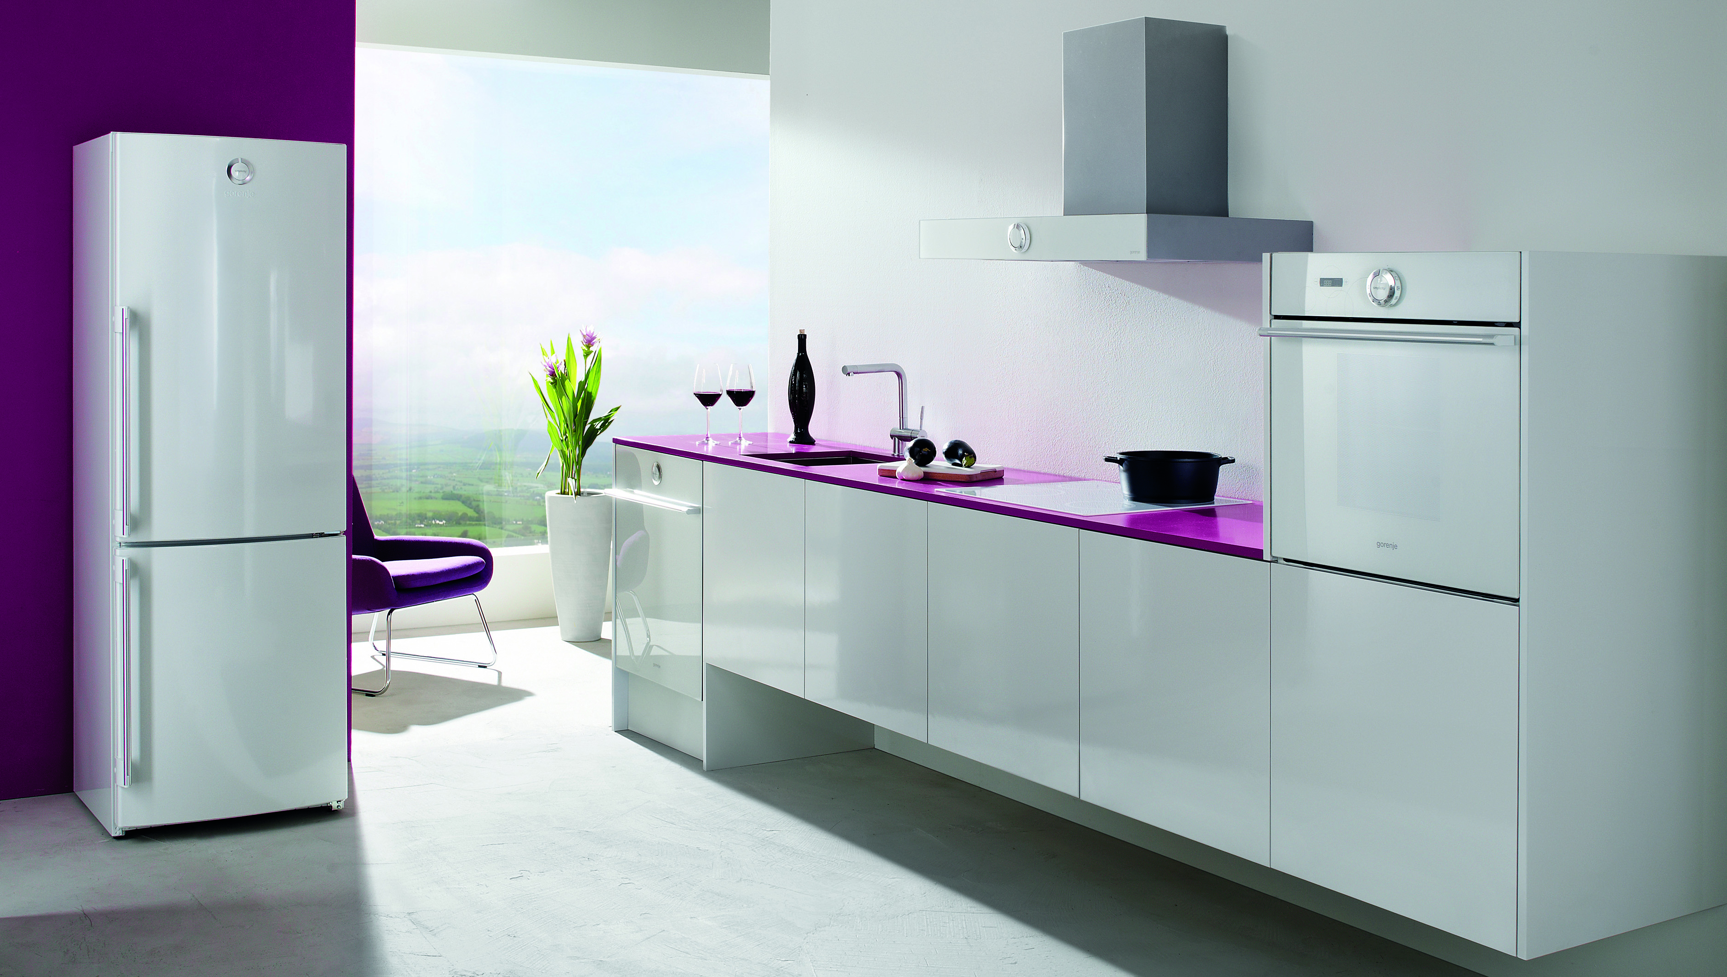
The SIMPLICITY line of appliances delivers a thoughtfully devised array of operation modes and programs, offering simple control with a single logical knob that will relieve you of the incessant dilemmas on which program to use. Simply choose the preset program, and the advanced UseLogic® technology will take care of the rest; hence, you will only pay for what you really use. In addition, these appliances are highly convincing with their economic and environment-friendly operation as their power efficiency ranks them in the highest A and A+ classes.

The careful and deliberate selection of preset programs, resulting from years of experience by European users, will prove convenient both for beginners and experience users who know exactly which features and functions of each appliance they actually need and employ. A combination of glass and precious metals ennobles the appliances with a plain, yet elegant and sophisticated appearance. The ergonomically designed dial, a hallmark of the collection, and the polished aluminium handle endow the entire collection, available in black or white, with a sense of harmonious coherence.

The Gorenje SIMPLICITY line of appliances includes a scrupulously though-out selection of products that deliver total comfort of use and consistent top-class performance: a built-in, A-rated multifunctional oven featuring a simple selection of the most suitable program; a built-in cooking hobs in several versions: induction, hi-light, or gas; an extractor hood, 60 or 90 cm wide; a fully integrated dishwasher complete with a decorative panel; a combined fridge freezer, energy class A+, also available featuring NoFrost; a washing machine offering spinning at up to 1400 rpm, 6-kg load and simple selection of the most suitable programs; a washing machine – slim version (depth 45 cm).

Gorenje SIMPLICITY appliances will simplify your life and save your time.

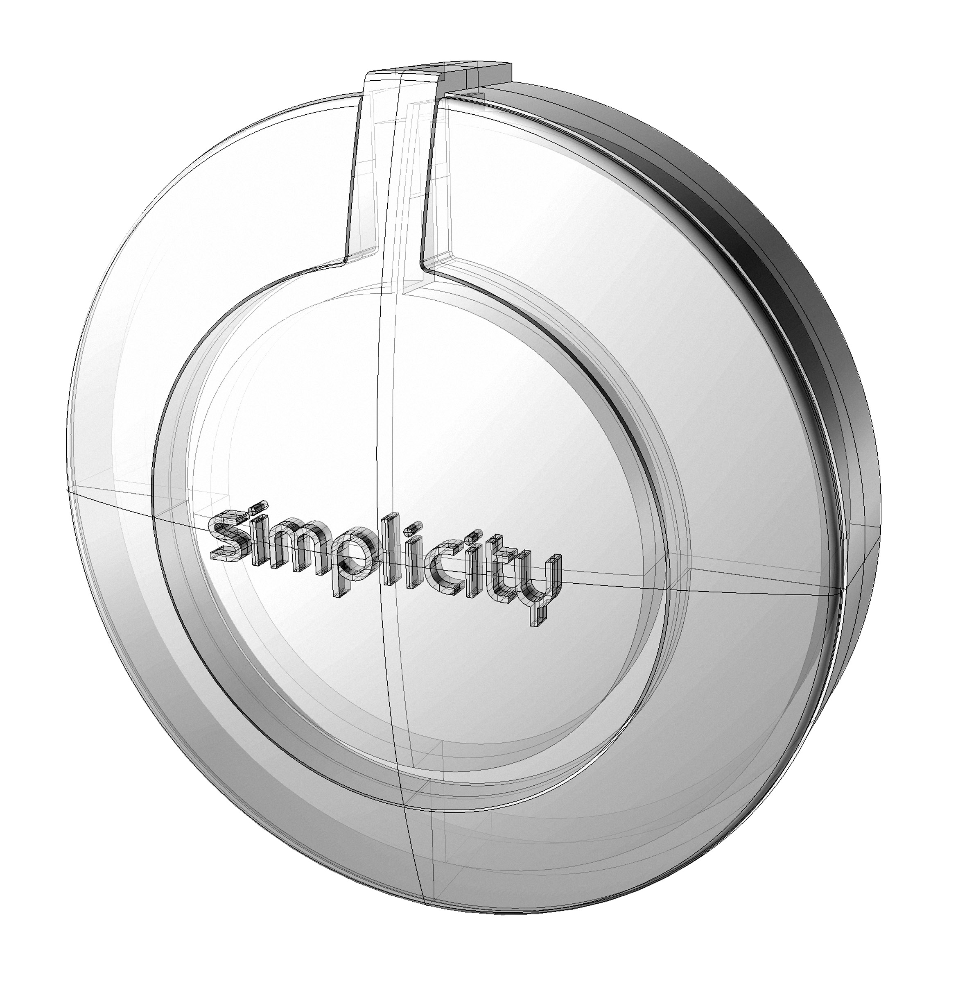
With a single logical knob
SIMPLICITY offers the most logical choices – the ones, being actually used. Just one attractive knob serves all.
With deliberate design
SIMPLICITY indulges your sight with well considered form and with genuine materials. Saves your energy with ergonomics: without unnecessary movements and time-consuming search of right selections.
With cost-effective operation
SIMPLICITY respects the environment: with low energy consumption, reduced water consumption, and with silent operation.
At reasonable price
SIMPLICITY is friendly to your purse: only what is really used, is paid. This is enabled with the state-of-the-art achievements, built-in the appliances.

###

ABOUT VOLUNTARY SIMPLICITY

Voluntary Simplicity is a manifestation of the saturation of the consumer

For ages, people have been the captives of their own dreams and endless desires. Immersed in their pursuit, we are grasping for air while hardly ever taking the time to take a deep breath. Yet, although we may often refuse to realize it, the insatiable quest for pleasure and fortune is inevitably paired with disappointment. But we can take charge of our lives; we can choose a different, simpler, better life. A life simple and uncomplicated, yet rich and full, is the contemporary philosophy of living, also called “voluntary simplicity”; across the world, the number of people that subscribe to it is growing.

Modern society saw the emergence of the “new consumers”. Influenced by the media and marketing, they seek happiness and inner peace through material goods, which however fail to deliver what the ads are promising, leaving behind an aching void inside the people who get lost in the twister of haste and alienation. The overwhelming offer of goods and superfluous information result in spending too much time and energy on pointless tasks, deciding between countless options of fictitious choice. Yet recent research has identified a twist in the mode of thought.

Today, money and status have plunged down the list of priorities for many, having been outranked instead by health, happiness, and living a socially accountable and fulfilled life. Or, as argued by one of the early advocates of a different lifestyle, Duane Elgin, author of ‘Voluntary Simplicity & The living Universe’: “Living in a way that is outwardly simple and inwardly rich.”

